DRAFT
FloodSAFE California
2013 Strategic Implementation Plan
California Department of Water Resources
Agreement No. 4600009146
Activity No. 120602
May 2013

Foreword
The California Department of Water Resources (DWR) is continuing to work towards reducing flood risks throughout California. FloodSAFE California is an important component of the DWR’s Integrated Water Management (IWM) initiative that is committed to achieving a sustainable, robust, and resilient flood and water management system for the benefit of all Californians.
With the hindsight of past FloodSAFE accomplishments, now is the time to revisit the future direction of the FloodSAFE Initiative with emphasis on DWR work over the next five years. This 2013 FloodSAFE California Strategic Implementation Plan (Plan) defines the vision, goals, and strategic approach to implementing an integrated program that will substantially reduce flood risks throughout the State. The Plan also describes measures that will work in concert to reduce chance of flooding.
By understanding the strategic plan for future work on the FloodSAFE initiative, partners, key stakeholders, and the public can more effectively participate in the flood management process. Through the successful implementation of an integrated flood management program as part of IWM, a broader range of real and lasting benefits can be realized more cost-effectively, improving public safety through reduced flood risk, enhancing environmental quality and ecosystems, and strengthening the State’s economy.
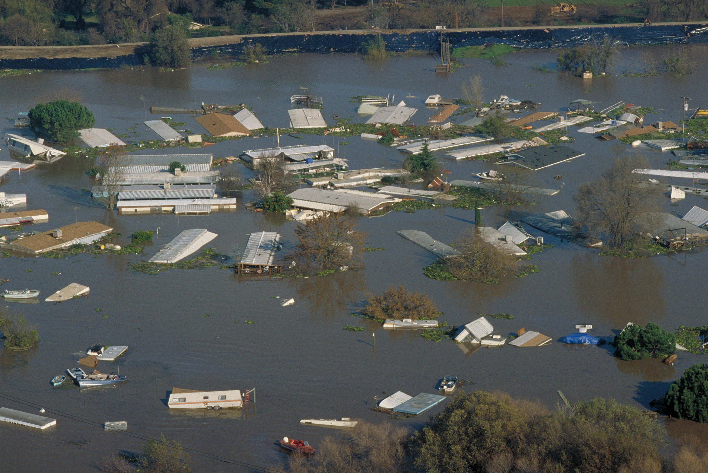
Flooding occurs in all regions of the State of California. In recent decades, however, as urban development has expanded into the floodplains, the consequences of flooding have become much more severe, causing major losses of both life and property. Since FloodSAFE’s launch, the State has been working with its partnering agencies to prepare to respond to floods, while concurrently implementing projects to increase flood protection and build flexibility and resiliency into the State’s flood management system to accommodate future flood events.
More than 7 million Californians and $580 billion in property are at risk of flood
FloodSAFE will maximize returns on the State’s investments by prioritizing its investment in areas facing the worst flood threats. As the State’s robust flood management program structure continues to evolve, its focus on effective deployment of staff, expanding collaboration and coordination among federal, State, and local water management entities, and leveraging funding and other resources and assets remain as its foundation. Combined with regular tracking and reporting of expenditures, accomplishments, and key performance indicators, FloodSAFE California continues its commitment to fiscal responsibility, accountability, and transparency.

Table of Contents
Foreword 1
Table of Contents i
Abbreviations and Acronyms iii
1 Introduction 1
1.1 Background 1
1.2 DWR Mission 1
1.3 Integrated Water Management 2
1.4 Strategic Plan Organization 3
1.5 Strategic Implementation Plan Purpose 3
2 California’s FloodSAFE Vision, Goal And Objectives 4
2.1 FloodSAFE Goals 4
2.2 FloodSAFE Objectives 4
3 FloodSAFE Implementation Framework 6
3.1 Implementation Programs 6
3.1.1 Flood System Risk Assessment and Engineering 6
3.1.2 Flood Management Planning 7
3.1.3 Floodplain Risk Management 9
3.1.4 Flood Risk Reduction Projects 9
3.1.5 Flood System Operations and Maintenance 11
3.1.6 Flood Emergency Response Program 12
4 FloodSAFE Investments 15
4.1 Recent Investments in Flood Risk Reductions 15
4.2 Future Investments 17
4.2.1 Investments Priorities 17
4.2.2 FloodSAFE Investment Strategy 18
5 Challenges and Opportunities in Implementing FloodSAFE Initiative 20
5.1 Sustainable Funding for Flood Management 20
5.2 Permitting Flood Projects and Reducing Transaction Costs 20
Appendix A Glossary 1
References 1

Tables
Table 1: FloodSAFE Investments – Spent and Committed 2007 – 2012 ($ in millions) 16
Table 2: FloodSAFE Planned Investments 2013 – 2017 ($ in millions) 19

Abbreviations and Acronyms
CVFPB Central Valley Flood Protection Board
CVFPP Central Valley Flood Protection Plan
DWR Department of Water Resources
EIP Early Implementation Projects
IWM Integrated Water Management
RFMP Regional Flood Management Plan
USACE United States Army Corps of Engineers

Introduction
This 2013 Strategic Implementation Plan defines FloodSAFE California’s vision, goals, and strategic approach to implementing an integrated program that will substantially reduce flood risks throughout the State.

Background
Major flooding is a threat throughout California. Catastrophic flooding in the Central Valley has been documented since the mid-1800s. Over the years, local, State, and federal entities have constructed a large network of levees, pumping plants, bypasses, dams, and other flood management facilities to help control and direct damaging flood waters. Construction of flood control structures along the Sacramento and San Joaquin river system started shortly after California became a State and continued through the mid-1950s, so much of the infrastructure that we rely on today is quite old. Most of these structures were built before modern-day engineering standards were developed and implemented.
While flood management infrastructure throughout California has been quite successful protecting areas from flood damage, occasional failures have been devastating. Due to development within historic floodplains, future damage could be even worse. For example, experts believe that California’s capital city of Sacramento is one of the most flood-prone cities in the nation.
Environmental considerations, institutional constraints, and aging infrastructure have placed increased pressure on California’s flood and water systems. Historically, water supply, flood risk management, and the ecosystem have been managed separately within a watershed. DWR has been working to discard this old planning model and work towards integrated solutions for California’s water issues.

DWR Mission
The California Department of Water Resources’ (DWR) mission is:
“To manage the water resources of California in cooperation with other agencies, to benefit the State's people, and to protect, restore, and enhance the natural and human environments.”
To fulfill this mission, DWR is committed to implementing IWM throughout its programs. Through IWM, DWR considers implementing programs and projects which can reduce flood risks while improving water quality and water supply reliability, fisheries and wildlife habitat enhancements, recreational opportunities, and energy reliability.

Integrated Water Management
Integrated Water Management (IWM) is a strategic approach to plan and implement water management programs that combines flood management, ecosystem enhancement, water supply, and other water management actions to deliver multiple benefits across watershed and jurisdictional boundaries. Such integration calls for bringing together multiple disciplines and interests to define problems and opportunities and then working creatively and collaboratively to achieve practical, cost-effective, and sustainable multi-benefit solutions.
DWR addresses today’s water management challenges facing the State through IWM initiatives that include FloodSAFE California.
Well-implemented integrated water management projects enjoy broader support and are thus less likely to be delayed or stopped during the implementation phase. They are more efficient and often qualify for funding from a variety of sources, thereby spreading costs among beneficiaries. They move through permitting processes more efficiently since regulatory input has been considered from project inception. Most importantly, they provide real and lasting benefits in terms of public safety, environmental stewardship, and economic sustainability.
Flooding can come in the form of torrential flash floods in the steep mountains and alluvial plains of Southern California, the inundation of floodplains in the Central Valley, or as high tides and devastating waves along the coastline. Catastrophic flooding has taken many human lives, drowned thousands of livestock and many thousands of acres of agricultural crops, and caused billions of dollars of economic losses to California’s business and agricultural industry over the years. Since 1950, there have been more than 50 State or federally declared flood disasters in California.
As recently demonstrated in the aftermath of hurricanes Katrina and Sandy, flooding can have long-lasting and devastating economic consequences that reach far beyond the boundaries of physical damage. The need to improve public safety through integrated flood management is urgent as more people live and work in flood-prone areas and climate changes make large flood flows more likely.
Integrated flood management, and important part of IWM, is an approach to managing flood risk that recognizes:
- Interconnection of flood management actions within broader water resources management and land use planning
- Value of coordinating across geographic and agency boundaries
- Need to evaluate opportunities and potential impacts from a system perspective
- Importance of environmental stewardship and sustainability

While DWR is leading FloodSAFE, successful implementation of the program depends on active participation from many key partners. Since its creation in 2006, FloodSAFE California has worked steadily to implement the long process of improving flood management systems and invested heavily in emergency repairs near several high risk urban areas, evaluated levees that protect urban areas, informed the public about flood risks, provided funds for implementation of projects and lead a sustained effort to improve integrated flood management statewide.
DWR does not have sufficient funds to achieve FloodSAFE objectives without substantial federal and local cost participation. Most of the State’s funds currently available to help implement FloodSAFE are provided by Propositions 1E and 84. The Legislature allocated these bond funds for specific purposes and regions, placing a high priority on improving flood protection and preparedness in the Central Valley and Delta as soon as possible due to the high potential of loss of life and property.

Strategic Plan Organization
The FloodSAFE California 2013 Strategic Implementation Plan describes:
- Section 2 describes California’s FloodSAFE Vision, Goals and Objectives for the next five years to guide action
- Section 3 describes the FloodSAFE Implementation FrameworkSection 4 describes The focus of future FloodSAFE Investments
- Section 5 describes Challenges and Opportunities in Implementing FloodSAFE Initiative

Strategic Implementation Plan Purpose
The purpose of the FloodSAFE California 2013 Strategic Implementation Plan is to document the shared vision and implementation approach of the FloodSAFE Initiative that can bring about a flexible, resilient flood management system for California. The Implementation Framework section describes the structure through which DWR implements specific actions, schedules, resources, partnerships and the coordination required over the next five years.

This Plan serves a broad audience: the Administration, Legislature, public, and California's flood managers at State, federal, tribal, and local levels. It will be updated periodically by DWR and its partners based on the input, experiences, accomplishments, and new information gained during implementation.

California’s FloodSAFE Vision, Goals And Objectives
A sustainable flood management system that substantially improves public safety, enhances ecosystems and promotes economic growth by implementing integrated flood management throughout California
This FloodSAFE California vision reflects the inter-relationship between flood management and public safety, economic vitality, and environmental stewardship. The vision reflects the future image for California flood management.

FloodSAFE Goals
Goals describe the broad and enduring values, direction, and desired conditions to which DWR aspires. The goals are aimed at meeting the FloodSAFE vision. The primary goals of flood management are aimed at protecting public safety.
The FloodSAFE goals are:
- Reduce Flood Risks – Reduce risks of flood damages to California communities, homes and property, agricultural/rural areas, and critical public infrastructure.
- Protect and Enhance Ecosystems – Improve flood management systems in ways that protect, restore, and where possible, enhance ecosystems and other public trust resources.
- Promote Flood System Resiliency, Flexibility, and Sustainability – Take actions that improve flood system flexibility and resiliency such that the system is capable of safely accommodates climate change and potentially larger floods in the future and can rapidly recover from flooding when that occur.
- Promote Economic Growth – Provide continuing opportunities for prudent economic development that supports robust regional and statewide economies without creating additional flood risk.
In order to guide specific actions, a set of FloodSAFE objectives have been identified to measure progress in meeting these continuous goals over the next several years.

FloodSAFE Objectives
The objectives describe what is to be achieved to solve the problems with the flood management system. The objectives guide selection of actions, projects, and investments to provide Californians with maximum public benefit while ensuring fiscal responsibility and accountability. The objectives are the basis for the FloodSAFE programs described in Section 3. By meeting the objectives, the FloodSAFE goals will be achieved.
DWR and its partners manage the probability side of flood risk with levees, dams, and other structures to minimize and control flooding. The consequence of flood risk is managed with more non-structural solutions, such as supporting land use decisions that locate development and people outside of floodplains and harm’s way and implementation of an effective emergency response program.

The FloodSAFE objectives are:

- Perform Analyses, Develop Tools and Data to Improve Understanding of the System - Ongoing and new tools, data, and evaluations will further improve understanding of hydrology, hydraulics, geotechnical, and other technical aspects of the flood management system.
- Prepare Plans and Feasibility Studies to Advance Projects – Planning, feasibility studies and other evaluations will be used to find cost-effective integrated multi-benefit solutions to improving flood management system facilities. Embedded in the planning process is the broad concepts of impact avoidance, protection of natural resources, mitigation of unavoidable environmental impacts, and restoration and enhancement of ecosystem functions
- Improve Floodplain Management – Provide flood risk information to land use agencies so they can make informed decisions and inform the public about flood risk within the floodplains
- Implement Physical Improvements to Flood Management Facilities – Partner with other entities to design and construct multi benefit physical improvements to existing facilities and new facilities as necessary to reduce flood risk and attain a sustainable flood management system.

- Improve Flood System Operations and Maintenance – Keep flood system facilities in good working order so they function as intended at times of high river flows while considering environmental stewardship.
- Improve Emergency Preparedness, Response, and Recovery – Improve flood emergency response and readiness for occasional flood emergencies that are likely to occur.

FloodSAFE Implementation Framework
To achieve the FloodSAFE objectives stated earlier, DWR has organized its resources and programs to effectively continue to manage the FloodSAFE Initiative. Some of the FloodSAFE programs have been part of DWR’s flood management for decades, while others were established to expedite implementation of the FloodSAFE Initiative. The implementation framework consists of six major programs intended to facilitate efficient and effective flood management improvements through better understanding of the flood management system, implementing projects that are critically needed, and improving flood management practices in an orderly fashion. These programs are:
- Flood System Risk Assessment and Engineering
- Flood Management Planning
- Floodplain Risk Management
- Flood Risk Reduction Projects
- Flood System Operations and Maintenance
- Flood Emergency Response

Cutting across these five programs, the implementation framework strives for:
- Regional geographic focus
- Coordination, communication, and active engagement with all programs’ partners
- Tracking of performance measurement

Implementation Programs

Flood System Risk Assessment and Engineering
Beginning in 2007, DWR has undertaken an extensive inventory of the flood management system and an engineering assessment of the State Plan of Flood Control (SPFC) facilities in the Central Valley. Risk assessments and engineering that support ongoing planning, evaluations, and refinement of the State System-wide Investment Approach (SSIA) will continue to be performed under this program. These assessments produce data and tools that are fundamental to planning, designing, and implementing flood risk reduction projects over the next few decades. The majority of the Central Valley flood management facilities, and nearly all of the SPFC facilities, are part of the State-federal flood protection system. Any modifications to these facilities will require federal participation and approval through the U.S. Army Corps of Engineers (USACE) and Congress, which should be supported by detailed engineering analyses.
The activities under this program will support and provide engineering tools, data, and foundational information through 2017 for:
- Documentation of the integrity of the flood protection system in the Central Valley
- Conducting hydraulic conveyance capacity evaluation of the flood channels and updating them every five years. Completing Urban Levee Evaluation activities
- Completing Non-Urban Levee Evaluation activities
- Inspection and LMA Reporting process improvements

Flood Management Planning
During the first phase of FloodSAFE, DWR’s Flood Management Planning Program developed two critical documents that have provided guidance to all FloodSAFE programs. The 2012 Central Valley Flood Protection Plan describes the State’s roadmap to achieve a high degree of public safety for over 1 million people and about $70 billion in assets in the Central Valley. In coordination with the U.S. Army Corps of Engineers, DWR also recently released a draft of California’s Flood Future: Recommendations for Managing the State’s Flood Risk. This document contains the first comprehensive look at flooding throughout the State, along with the challenges, opportunities, and recommendations for improving integrated flood management.
During 2013 through 2017, the Flood Management Planning Program will continue developing additional details of these visionary plans through the following:
- Central Valley Flood Management Planning - The Central Valley Flood Management Planning Program will launch several major efforts to refine the SSIA described broadly in the 2012 CVFPP. These efforts will be closely coordinated and include:

  - Regional Flood Management Planning - State and local agencies have initiated Regional Flood Management Planning covering six regional areas receiving protection from SPFC facilities. This locally led effort will define regional flood management needs and articulate regional priorities, prepare a regional financing plan including local financing capacity, and establish improved regional governance for implementation.

  - Basin-Wide Feasibility Studies - FloodSAFE will lead the development of two Basin-Wide Feasibility Studies in the Sacramento River and San Joaquin River basins. The Basin-Wide Feasibility Studies will refine the size and location of large-scale flood system improvements and conservation actions identified in the CVFPP to improve overall flood system function, flexibility, and resiliency. The studies will also assess State interest in system and regional flood improvements, identify key elements of the SSIA that can be incorporated into ongoing federal cost-share feasibility studies, and explore implementation considerations.

  - Central Valley Flood Protection Plan Update - The 2017 update of the CVFPP will be prepared by December 2016. The updated plan will incorporate information from the above-described SSIA refinement efforts, reflect the accomplishments of implementation efforts to date, and identify flood management improvements to be made in the subsequent five-year cycle. Several documents will accompany the 2017 CVFPP update:

    - An update of the State Plan of Flood Control Descriptive Document to report changes in the SPFC
    - An update of the Flood Control System Status Report to document changes in facility conditions and assessments
    - A Financing Plan that will document how continued implementation of the updated CVFPP will be financed
    - Environmental documentation, if necessary, to support the updated plan and for implementation of the recommendations in the updated plan

- Central Valley Flood System Conservation Strategy - DWR is developing the Conservation Strategy to document the approach for implementing the environmental objectives of the Central Valley Flood Protection Act of 2008, providing the systemwide context for improving environmental conditions and trends. The Conservation Strategy will include measurable conservation objectives and regional conservation actions. The objective is to develop conservation actions that would mitigate the impacts of the SSIA implementation and would enhance ecosystem; hence SSIA will be self-mitigating and will provide support regulatory approvals needed for SSIA implementation. Integration of the Conservation Strategy with SSIA implementation will help proactively improve environmental conditions from a systemwide perspective, thereby eliminating compensatory mitigation needs for individual projects. The Conservation Strategy is scheduled to be completed in 2014.

- Statewide Flood Management Planning - During the last three years, a major effort was undertaken to prepare an inventory of flood risks facing Californians. The findings of this investigation were documented in the California Flood Future report. DWR will continue planning activities through 2017 to include:

  - Further refine management actions identified in California's Flood Future report through collaboration with various Integrated Regional Water Management (IRWM) Planning groups statewide
  - Promote flood management delivery at the watershed level by helping IRWM groups integrate flood management, water management, and ecosystem restoration at the regional level
  - Support preparation of the Statewide Flood Management Financing Plan
  - Identify and develop specific program deliverables through 2017

- Delta Flood Management Planning - In addition to statewide flood management investigations, the Delta Knowledge Improvement Program (DKIP) will be funding specific studies with public agencies to fill the data gaps identified in the Delta Risk Management Strategy. Ultimately, the studies and investigations funded by DWR will help to better characterize the probabilities and consequences of levee failures in the Delta region. The information developed in the DKIP will be essential for guiding the Delta-wide efforts to reduce the chance and consequence of flooding, the protection and enhancement of ecosystems, and the promotion of sustainability and economic growth.

Floodplain Risk Management
The Floodplain Risk Management Program strives to reduce loss of life and property and to protect natural resources and beneficial functions of floodplains. FloodSAFE is investing available funding and leveraging cost-share from FEMA in the Floodplain Risk Management Program to improve the management of floodplain activities throughout California in a manner that reduces the consequences of flooding. To meet the FloodSAFE objectives of reducing flooding consequences and promoting a sustainable floodplain management system, DWR will continue to provide technical assistance to local agencies for evaluation and delineation of floodplains to enhance their near- and long-term land use planning activities. Over the next five years, these activities will include:
- Floodplain Management in the Central Valley - During the second phase of the FloodSAFE implementation, DWR will continue to actively engage FEMA in floodplain management in the Central Valley. DWR will work with FEMA to:
  - Secure additional federal funds
  - Prepare maps for high priority areas
  - Provide notification to certain property owners within Levee Flood Protection Zones
  - Finalize and implement the Urban Level of Flood Protection Criteria and Urban Levee Design Criteria
- Floodplain Management Statewide – DWR will work with FEMA and local agencies to:
  - Promote a more equitable insurance implementation that reflects the corresponding flood risks
  - Provide technical information to conduct alluvial fan floodplain evaluation
  - Conduct coastal A-zone floodplain evaluation
  - Prepare floodplain maps such as Levee Protection Zones and Awareness Maps to assist local decision makers with avoiding development of flood hazard areas
  - Promote sound flood management policies to reduce development and associated flood risks in the floodplains
  - Conduct targeted outreach to inform the public about their flood risks

Flood Risk Reduction Projects
The Flood Risk Reduction Program provides financial assistance for development of on-the-ground projects that are consistent with FloodSAFE objectives and the 2012 CVFPP. These projects can be repair or improvement of existing facilities, development of new facilities, and enhancement of flood system ecosystem, and could be structural or non-structural. Projects could be implemented by the local and regional agencies through a partnership program where the State provides grant assistance to local partners or it could be direct investment by the State with participation of the Central Valley Flood Protection Board and USACE. An important element of the 2013 to 2017 phase of FloodSAFE implementation is full consideration of an integrated approach to flood management where multi-objective project implementation is promoted.
- Flood Risk Reduction Programs for the Areas Receiving Protection from State Plan of Flood Control Facilities. FloodSAFE will continue working on the following programs through 2017:
  - The High Risk Urban Flood Risk Reduction Program will support implementation of regional flood damage reduction projects for urban areas in the Central Valley to achieve an urban level of flood protection (protection from a 200-year flood).
  - The State has been working with USACE on Major Capital Outlay Projects. DWR, Central Valley Flood Protection Board, USACE, and local agencies will continue working on feasibility studies and major capital improvements to upgrade the facilities of the SPFC.
  - The Small Communities Flood Risk Reduction Program will assist regional partners in development of flood damage reduction projects for small communities that are consistent with SSIA, implementable, multi-objective, and have been shown to be feasible.
  - The Systemwide Improvement Program is established to implement projects that lower flood stage throughout the flood management system in the Central Valley to reduce flood risks, add resiliency to the flood management system, and the capacity to manage larger floods in the future. Typical projects include management actions that facilitate reservoir reoperations to lower peak flood flows downstream of the reservoirs, modification and expansion of flood system structures, and extension and expansion of the bypass system to add channel capacity and resulting lower flood stage. Implementation will require acquisition of flood and conservation easements. An important element of this program is the enhancement of ecosystem within the bypass system to provide for wildlife habitat, fish passage, and connectivity of habitat within the flood management system.
  - Feasibility Study and Design Local Assistance is established to assist local agencies in advancing their projects to feasibility and design stage. This program is designed to provide financial assistance for projects that could reduce flood risk for areas receiving protection from State Plan of Flood Control facilities.
- Statewide Flood Risk Reduction Programs – FloodSAFE will continue working with local agencies to implement projects to provide additional flood protection along streams outside of the Central Valley, including:
  - Flood Control Subventions Program outside the Central Valley provides cost-sharing assistance to local agencies toward the capital cost of non-SPFC federally authorized construction. DWR will continue to work with USACE, Natural Resources Conservation Service, and the local agencies in the implementation of these projects.
  - Local Levee Assistance Program–Statewide assists local agencies by providing financial assistance for evaluation, design, repair, and improvement of local non-SPFC levees throughout the State, including the Central Valley.
  - The Delta Levees System Integrity programs are focused on levee repair, maintenance, and improvement through the Delta Special Flood Control Projects that are designed to protect Delta islands from flooding where levees help protect the State’s water supply along with other significant statewide assets. The Delta Levees Maintenance Subventions Program provides State assistance to local agencies for maintenance of nearly 700 miles of levees annually.

Flood System Operations and Maintenance
The Flood System Operations and Maintenance Program operates and maintains levees, channels, hydraulic control structures, pumping plants, and bridges that are considered facilities of the SPFC. DWR is responsible for maintaining specific facilities either at the direction of the Legislature (California Water Code Section 8361) or as a Maintenance Area. Maintenance Areas are formed and staffed by DWR when there is no local maintaining agency (LMA) performing required maintenance. Other SPFC facilities are maintained at the local level in accordance with agreements with the CVFPB.
Routine maintenance of project facilities is an essential component of flood system preparedness. Program activities to meet near-term priorities and carry-out routine operations and maintenance through 2017 include:
- Flood System Preparedness - focuses on completing all routine maintenance activities, repairing damages that could undermine facility integrity, and having adequate flood fighting supplies on hand before the onset of the next flood season.
- Facility Evaluation and Rehabilitation - DWR has developed the Flood System Repair Program (FSRP) to help LMAs reduce flood risks by providing technical and financial support to repair documented critical problems of SPFC facilities. DWR will yearly, after the end of the flood season, compile and update a list of all potential repair sites within the SPFC facilities. DWR will cost share with LMAs to repair sites that meet standardized screening criteria. In support of this program, DWR joined with local agencies and the Central Valley Flood Protection Board to review and develop criteria for rural agricultural levee repairs. The discussion is in its early stage.
- Flood System Channels and Structures Evaluation and Rehabilitation
  - To ensure that channels and bypasses of the Sacramento River Flood Control Project are being adequately maintained, DWR will evaluate the flow capacity of the flood channels on a five-year rotation schedule. Where channel flow capacity does not meet design objectives, plans will be developed to restore capacity flows by a combination of sediment removal and vegetation management.
  - Corridor Management Strategy (CMS) is a developing concepts for integrating environmental stewardship and system sustainability into flood channel management plans to develop a long-term, integrated, self-mitigating, operational model for the management of flood control projects. It involves assessing: 1) the existing flood channel habitat and geomorphology, and 2) identifying how the channel could be better managed in terms of flood maintenance, flood operations, and ecosystem functions. Projects under study are the Lower Feather River Corridor Management Plan and Willow Slough Bypass Channel Rehabilitation Project.
  - DWR will inspect bridges, culverts, weirs, and other hydraulic control structures. If damages to structures present an immediate threat to their integrity and repairs are beyond the scope of routine maintenance, the repairs may be eligible for funding under the FSRP; otherwise, funding will be sought under the Capital Outlay process.

Flood Emergency Response Program
Improving flood emergency response throughout California is one of the major elements of the FloodSAFE Initiative. The Flood Emergency Response (FloodER) Program is implemented in close coordination with other State, federal, and local agencies with responsibility for flood management; as collaboration, coordination, and integrated operation of emergency response are the core tenets of the program and culture. To maintain a high degree of readiness to respond at any time to flood emergencies, DWR will conduct annual training, proactive pre-season coordination with cooperating agencies, annual review and replenishment of supplies and equipment, thorough documentation, dedicated data collection and information dissemination, and continuing efforts to improve all aspects of program performance.
- Flood Emergency Response Program Enhancements - Improving flood emergency preparedness, response, and recovery entails a host of engineering and emergency response activities. Many of these activities are conducted routinely by the staff through the base programs. And many are new and considered further enhancements of FloodER. Highlights of some of the major enhancement activities identified for implementation during the next five years include the following:

  - Flood System Vulnerability Assessments and Documentation - DWR will continue its significant progress to improve flood project integrity and assess flood system vulnerability, including enhancements to our combined inspections and reporting program, and documentation of the flood management system.
  - Flood Forecasting Support - DWR will continue development of an enhanced suite of flood forecasting tools. Among the tools are hydrology and hydraulic models and flood routing. Some key enhancements include development of an enhanced watershed model for the Feather River, developing a PRMS snowmelt model for San Joaquin River watersheds, and developing a ResSim model for San Joaquin River reservoirs. In coordination with NOAA and Scripps, DWR will develop models and tools to process atmospheric river data into early warning storm event parameters.
  - Real-Time Data Collection and Management of Planned Enhancements include the following:
    - The California Data Exchange Center (CDEC), a comprehensive flood information management center for California, will be thoroughly evaluated to ensure adequate system redundancy. Most data collected for flood forecasting and flood operation are through satellite and internet.
    - DWR will look to expand the data collection system in response to enhancements proposed by the CVFPP and California’s Flood Future Report. DWR will explore incorporating new technology and an advance flood warning system into standard operating procedures.
    - DWR will continue efforts to quantify the impacts of climate change on California’s hydrology and provide useful context and parameters for planning efforts in flood and water management.
  - Coordinated Reservoir Operations Enhancements - Reservoir operation throughout the State and specifically in the Central Valley plays a critical role in flood management and in reduction of flood stages downstream. The Forecast-Coordinated Operations (F-CO) program will result in improvements to both the reservoir release forecasting and coordinating the operation with other reservoir operators in the system. Work on F-CO of the reservoirs will continue and expand during the next five years. To successfully implement F-CO and Forecast-Based Operations, a suite of tools is being developed to facilitate reservoir operations coordination. These tools include reservoir operation models, dashboards for use during flood events, and development of a coordinated operation protocol accepted by all parties involved.
  - Flood Event Decision Support – A decision support system is commonly considered to include design, development, and deployment of suites of integrated user interfaces, analysis tools, and visualization and reporting systems. Dashboards are being developed and used for the F-CO program and play a key role in reservoir operations, river forecasts, and in the Flood Operation Center (FOC) during flood events. Another critical FOC need is development of a system to deploy, manage, and track resources and information during the floods. The FOC Flood Emergency Management System will be developed and used for deployment of trained staff to various flood response activities, will track resources used for each incident, and will track and report incident costs for proper incident cost recovery from the Federal Emergency Management Agency, all in real-time.
  - Flood emergency management planning and preparedness- Major efforts are underway to improve flood response readiness at the State level. In addition, local assistance will be available to prepare local flood emergency plan, communication tools and processes and interagency communication during flood events.
- Delta Specific Flood Emergency Preparedness, Response, and Recovery – Many activities are being undertaken to prepare and respond to the flood events in the Delta, including training, exercises, and developing proper tools, procedures, and plans for State, federal, and local responders. Some of the major enhancements for flood emergency preparedness and response include assisting local agencies to prepare local flood emergency response plans throughout the State including the Delta, developing a flood emergency management plan for the Delta, and the designing, constructing, and implementing facilities to stockpile and allow land/water transfer of flood emergency response materials and supplies in multiple locations in the Delta.

FloodSAFE Investments
Traditionally, the State’s flood system management responsibilities have been funded through State General Funds and bond measures. These funds were insufficient to keep pace with the State’s infrastructure and flood protection needs and demands. Instead, flood risk reduction programs and infrastructure need steady, reliable, long-term funding to achieve and sustain the requisite level of protection.

Recent Investments in Flood Risk Reductions
During the initial five years of the FloodSAFE Initiative, various flood risk reduction programs were funded and implemented with significant achievement. Because California, and particularly the Central Valley, faced immediate public safety threats from flooding, DWR pursued needed projects and critical levee repairs that would fit into a larger system-wide improvement. The Early Implementation Program increased flood protection for approximately 300,000 people in the Sacramento-San Joaquin river basins. In addition, bond funding support increased flood protection to approximately 3.4 million people outside the Central Valley.
In conjunction with these projects, DWR began pursuing long-term responses by developing tools, models, and data that are building blocks for designing and implementing projects that will reduce flood risks and enhance the ecosystem in California. As discussed in this report, the keys to thoughtful and thorough planning and effective action to reduce flood risks are tools sophisticated enough to gather and analyze data about the extreme variability in California’s geography, hydrology, and climate. Those tools and data enabled DWR, with input from the public and hundreds of stakeholders, to develop the Central Valley Flood Protection Plan and the California’s Flood Future report. A CVFPP companion document is the Conservation Framework to map environmental enhancement investments associated with the facilities of the State Plan of Flood Control. Further refinement of the tools and data has allowed DWR to begin initiating both regional and basinwide flood management improvement efforts.
Table 1 presents FloodSAFE (State contributions) expenditures by program from July 1, 2007, to June 30, 2012. As stated in this report, much has been accomplished in the past five years to address California’s most critical flood threats; however, much more work will have to be done. Of critical importance will be establishing stable sustainable funding to address statewide flood management needs.

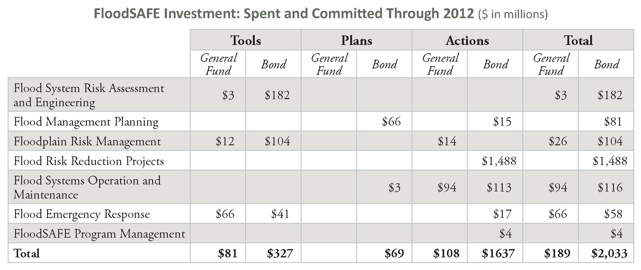
Table 1: FloodSAFE Investments – Spent and Committed
2007 – 2012 ($ in millions)

While accomplishments to date have been extensive, considerable additional effort and funding will be needed to design and construct multi-benefit flood management projects in the future.
Flood management is at a crossroads in California. We are moving away from fragmented implementation efforts and narrowly focused projects, toward an integrated approach to flood management that requires reliable funding. An IWM approach provides improved public safety, supports ecosystem enhancement, helps promote broad public and stakeholder support, and requires sufficient and stable funding to help manage flood risk.
Historically, flood management funding in California has been unstable and has increased or decreased depending on the health of State and federal budgets. Uncertainties in funding and responsibilities resulted in a lack of a long-term vision and a comprehensive implementation program to address long-standing flood infrastructure deficiencies. Now, for the first time, a comprehensive and visionary plan (the 2012 Central Valley Flood Protection Plan) has been developed for improving flood protection for areas protected by SPFC facilities and a statewide assessment of flood system improvement needs has been completed and documented in the California’s Flood Future report.
Both the Central Valley Flood Protection Plan and the California’s Flood Future report estimate the level of investment needed to provide an adequate level of flood protection for California citizens. The Central Valley Flood Protection Plan estimates approximately $17 billion will be needed to implement its recommended improvements to SPFC facilities. This value is a component of the $100 billion statewide flood management investment need estimated in the California’s Flood Future report.

Future Investments
DWR will prepare a financial strategy to address long-term, self-sustaining, and reliable funding needs for FloodSAFE. As a part of this financial strategy FloodSAFE will:
- Continue to engage federal and local partners to develop a cost-sharing strategy that is consistent with the corresponding roles and responsibilities of each agency.
- Work closely with the State Legislature and Congress to develop appropriate authorizations and appropriations to support the sustainable funding strategy.
- Recommend strategies and policies to consolidate local reclamation districts at the broader flood protection zones to leverage resources and improve efficiencies.
- Recommend policies for developing assessment strategies to provide for sustainable funding for operation and maintenance of the flood control facilities.
Adequate funding from local agencies may require creation of assessment districts to implement capital improvements or to support effective, efficient, and improved system operations and maintenance. It is anticipated that another State bond measure will be required to augment federal and local agency funding in order to adequately finance flood risk reduction projects.

Even with this approach, DWR recognizes that governments at all levels are struggling with heavy debt burdens and rising construction costs. It is unlikely that federal funding for any major new flood management projects will be available in the near future. These and other factors contribute to the uncertainty in future implementation for the FloodSAFE programs and projects.

The 2012 Flood Future Report estimates that more than $50 billion will be needed to fund high-priority flood risk reduction projects that have already been identified by State, federal, and local partners. However, this estimate likely is incomplete as many flood management projects needs are not fully identified or evaluated. Included in the $50 billion estimate, the 2012 CVFPP describes the State’s System-wide Investment Approach that alone will require up to $17 billion during next 20 years for flood related projects and activities.

Investments Priorities
Difficult investment decisions must be made to ensure that the highest priority projects are identified and funded. It is in the State’s interest to invest available funds proactively and effectively to avoid and mitigate for known risks, to reduce costly emergency response and recovery, and to obtain the greatest return on its investments by funding projects that provide multiple benefits. Limited funding requires careful prioritization of investments, leveraging various funding opportunities through implementation of integrated multi benefit programs and with primary drivers for the FloodSAFE program being:

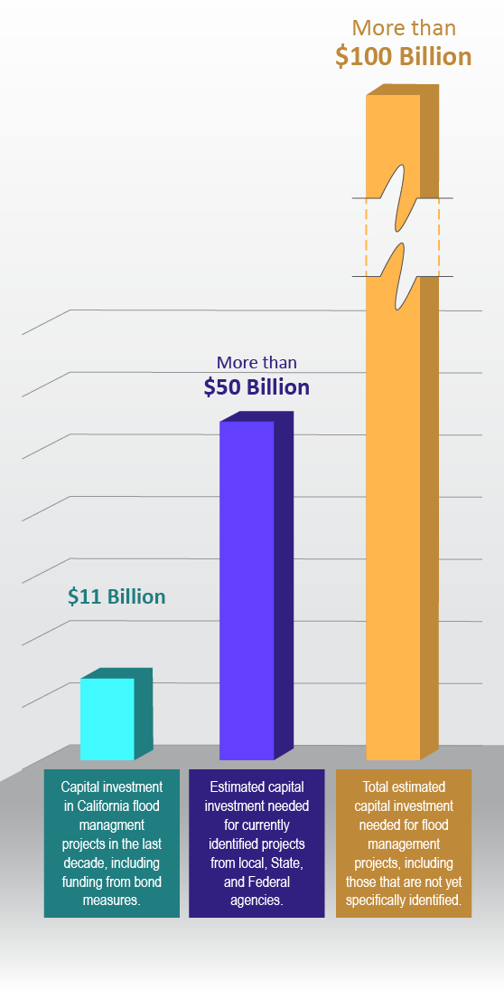
- Risk to human lives and public health
- Risk to State and local communities, properties, and infrastructure
- Improving flood management for small communities and rural agricultural areas
- Protecting and enhancing environmental resources
- Creating a flood management system that is more flexible and resilient.
Figure 1 shows the gap in funding and the capital investment needed for currently identified projects. It is expected that the current bond funding will support flood management programs through 2017. DWR is preparing a Five-Year Resource Plan for FloodSAFE to align resources with program needs

FloodSAFE Investment Strategy
Proposition 1E requires maximizing leverage of State funds through federal and local cost-shares in flood management projects. Coordination, communication, and integration across a number of programs and agencies also present opportunities for leverage through collaboration, minimizing duplication, economies of scale, and identifying other funding opportunities. DWR will continue to identify and pursue opportunities to maximize investments by partners in supporting California’s flood management projects.
Figure 1: Flood Investment Funding Gap
Engineering assessments and planning investigations conducted during the last five years provided a vast amount of engineering data, knowledge about operational constraints and facility deficiencies, and a better overall understanding of flood management infrastructure in California. With an increased understanding of flood management issues, DWR has conceptually prioritized its flood management investment of remaining bonds for 2013 through 2017, as summarized in the table below.
The $4.3 billion made available by Propositions 84 and 1E to FloodSAFE is a good down payment; however, additional funding is needed to address California’s flooding challenges. A new bond law (augmented by other revenue streams) will be needed for DWR to continue reducing flood risks for our citizens, businesses, and our infrastructure while continuing to enhance our ecosystems and plan for climate change adaptation strategies that will provide long-term flood system and ecosystem sustainability. Table 2 shows estimated State government expenditures by program from 2013 through 2017.
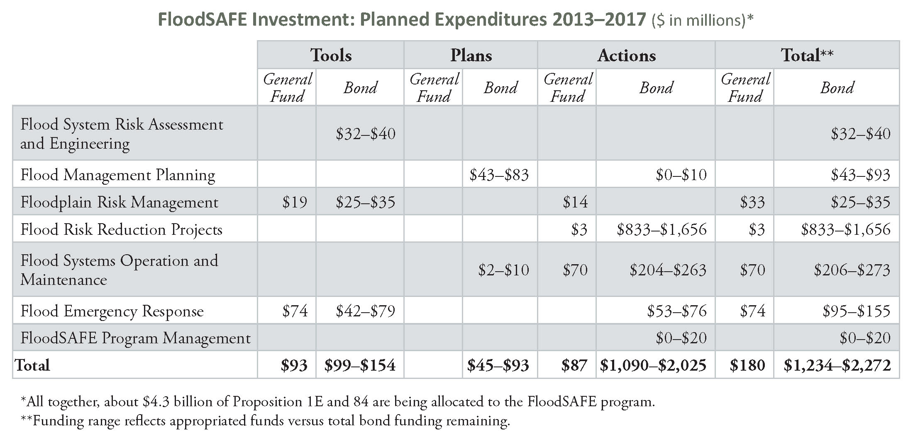
Table 2: FloodSAFE Planned Investments
2013 – 2017 ($ in millions)

Challenges and Opportunities in Implementing FloodSAFE Initiative

Sustainable Funding for Flood Management
Historically, California has relied on various sources to fund the flood infrastructure improvements, including the State General Fund, State bonds, local agencies, and the federal government funding. These sources of funding have not been reliable and are subject to the financial well-being of the federal and State government. Passage of Propositions 1E and 84 in 2006 has helped the State to implement projects to reduce flood risks throughout the State, but federal funding for the cost-sharing of these projects, in most cases, has not been available.
Operation and maintenance of the flood management facilities are generally the responsibilities of the local agencies such as reclamation districts, levee districts, and flood control districts. Many of these local agencies lack adequate funding sources to proactively address their maintenance issues.
Considering budgetary issues and pressure to reduce the budget deficit, federal funding of any major new flood management facilities will be unlikely in the foreseeable future. California must reassess opportunities that would allow continuing to make significant investments over the next couple of decades to improve the State’s aging flood infrastructure. Current fractured local maintaining agencies structure and funding should also be reevaluated to ensure adequate resources are available for a proactive maintenance of the flood management facilities. Consolidation and LMAs to ensure leveraging use of existing resources, additional bond measures, and statewide or regional flood protection fees and assessments should all be considered and evaluated to provide continuity and predictability of funding to provide flood protection for our communities around the State.

Permitting Flood Projects and Reducing Transaction Costs
Permitting flood management projects are time consuming and costly. Compliance with California Environmental Quality Act, National Environmental Policy Act, State and Federal Endangered Species Acts, Federal Clean Water Act, and many other permits is a major undertaking. In addition, any modifications of the State - Federal Flood Control Projects are subject to USACE 408 permit requiring extensive engineering analyses and evaluations by USACE staff. These permits have also considerably increased the transaction costs of the projects. It is estimated that transaction costs of the flood projects, today, are generally over 25 percent of the total projects costs.
Opportunities for reducing project transaction costs and shortening the implementation schedule may include the following:
- The State needs to continue implementation of integrated flood management that incorporates flood risk reductions with ecosystem restoration and enhancement at the watershed level. This strategy includes formulating projects at the watershed level and engaging permitting agencies in the early stages of planning to incorporate ecosystem enhancements into the project planning. This planning strategy could be designed to make flood management project self-permitting. This may require additional coordination and collaboration with permitting agencies at the onset of planning and design of the projects but in the long-term can reduce transaction costs and time needed for planning and permitting of the flood risk reduction projects.
- A process needs to be formalized with USACE to allow project feasibility studies and design to be conducted at the local and State level. The USACE will have the quality assurance role of the project design prior to issuing a 408 permit. Such a process could considerably reduce project feasibility and design schedule as well as transaction costs.
Many flood management challenges lie ahead and require diligent coordination and collaboration among all partnering agencies to be overcome. FloodSAFE will work closely with its partners to resolve barriers and will collaborate with them to reduce flood risks in California.

- Glossary
Basin-wide Feasibility Studies: State-led Basin-wide Feasibility Studies will focus on refining the CVFPP's system elements to improve the overall performance of the system in managing large floods, while providing greater resiliency with respect to climate change and other uncertainties.
Best Available Maps (BAM): Displays available information about 100-, 200-, 500-year floodplains for areas located within the Sacramento-San Joaquin Valley watershed.
Central Valley Flood Protection Plan (CVFPP): An integrated system-wide flood management plan for the Sacramento-San Joaquin River Flood Management System required by Senate Bill 5, the Central Valley Flood Protection Act of 2008.
Delta: An expansive inland river delta and estuary formed by the Sacramento and San Joaquin rivers that include a large expanse of interconnected channels, streambeds, sloughs, marshes, and peat islands.
Early Implementation Program (EIP): State co-funding for shovel-ready flood risk reduction projects within the State Plan of Flood Control.
Ecosystem Restoration/ Environmental Restoration: The process of improving the structure, function, and composition of the natural environment.
Environmental Stewardship: A concept and commitment of responsibility to manage and protect natural resources (water, air, land, plants, and animals) and ecosystems in a sustainable manner that ensures they are available for future generations.
Facilities of the State Plan of Flood Control: The levees, weirs, channels, and other features of the federally and state-authorized flood control facilities located in the Sacramento River and San Joaquin River drainage basin for which the board or the department has given the assurances of nonfederal cooperation to the United States required for the project, and those facilities identified in Section 8361 of the Water Code. (California Public Resources Code Section 5096.805)
Flood Hazard Mitigation: Assist rural and small communities in becoming more flood resilient.
Flood Control: Measures taken to reduce flood damage by managing and controlling large flows and routing those flows away from people and property as quickly as possible.
Flood Protection Corridor Program: A program that funds, primarily nonstructural flood management solutions, through direct expenditures and grants to local public agencies and nonprofit organizations.
Flood Risk: The probability of flood multiplied by the expected consequences of flood, over a range of floods.
Flood Risk Notification: Under State law, a flood risk notice must be sent each year to properties located behind any State-Federal levee and within a Levee Flood Protection Zone (LFPZ).
FloodSAFE: A multi-faceted initiative launched by the State of California in 2006 to improve public safety through integrated flood management.
Flood System Flexibility: The ability of the flood management system to adapt to changing conditions, such as changing hydrologic, social, political, regulatory, or ecologic conditions.
Flood System Resiliency: The ability of the flood management system to continue to provide benefits and/or recover quickly after damaging floods.
Floodplain: A flat or nearly flat area adjacent to a stream or river that experiences occasional or periodic flooding or potential flooding for areas protected by levees.
Floodplain Management: Actions designed to reduce risks to life, property, and the environment due to flooding. Actions can include watershed management, infrastructure construction and operation, variations in land use practices, floodway designations, etc.
Level of Protection: A designation of the ability to withstand a flood event of a certain magnitude and frequency of occurrence.
Non-urban: An area in which there are less than 10,000 residents.
Preparedness: Efforts to help reduce the adverse consequences of floods and to allow for quicker recovery after flooding.
Proposition 1E: The “Disaster Preparedness and Flood Prevention Bond Act of 2006” passed by the California voters on November 7, 2006, and as set forth in Division 5 of the Public Resources Code.
Proposition 84: The “Safe Drinking Water, Water Quality and Supply, Flood Control, River and Coastal Protection Bond Act of 2006” passed by the California voters on November 7, 2006, and as set forth in Division 43 of the Public Resources Code.
Recovery: Efforts taken after flooding has occurred to return an area to pre-flood conditions.
Regional Flood Management Plans (RFMPs): The long-term flood management vision for a region that includes strategies, priorities, and implementation steps needed to achieve a “flood safe region.”
State Plan of Flood Control (SPFC): The State and federal flood control works, lands, programs, plans, policies, conditions, and mode of maintenance and operations of the Sacramento River Flood Control Project described in Section 8350, and of flood control projects in the Sacramento River and San Joaquin River watersheds authorized pursuant to Article 2 (commencing with Section 12648) of Chapter 2 of Part 6 of Division 6 for which the board or the department has provided the assurances of nonfederal cooperation to the United States, and those facilities identified in Section 8361. (California Public Resources Code Section 5096.805)
Urban: A developed area in which there are 10,000 residents or more.

References

